RConnectionServ API Functional Specification
Security Classification: | <Confidential> | Team/Department: | <Converged Comms>
Document Reference: | <SXX.XXXnnn.nnn> | Author(s): | <Viki Turner, Robert Lundie>
Status: | <Draft> | Owner(s): | <Comms Framework TA>
Version: | <0.2> | Approver(s) | <Petr Smrz, Feroz Uddin>
Last Revised Date: | <2008> <03> <18> |  | <Petr Smrz, Feroz Uddin>

Introduction
RConnectionServ is the API for a new server in Esock that performs general activities for application level clients in the management plane of the Comms Stack.
This new API joins RSocketServ, RSocket, RHostResolver, RConnection and RSubConnection and should be regarded in many ways as a partner to the Socket Server RSocketServ API

Scope
This document describes the intended purpose of the new RConnectionServ API and lists and describes the functionality currently supported by this interface-
- To connect to a particular provider in the management plane
- To query status of properties within the management plane e.g. Availability
- To receive notifications of changes to properties within the management plane
Examples of the use of this API are given in the accompanying HowTo document [R3].

Conventions, assumptions and terminology
It is expected that the reader has a basic understanding of the Symbian OS comms framework and its entities e.g. Connection, Subconnection, Provider.

Overview of the API Purpose and Function
RConnectionServ performs general activities for application level clients in the management plane of the Comms Stack. RConnectionServ exists as a new server in the comms process for non-time-critical management operations. This means that time-critical control and data operations can still be performed through RsocketServ without disruption to ongoing data flows. The RConnectionServ API performs activities for application level clients that relate to:
- groups of Connections and SubConnections, such as enumerating all connections on the device or at a particular Tier
- activities performed in the Management Plane within the comms stack such as Availability notification.
For queries and commands to a specific Connection or SubConnection, clients should use the RConnection and RSubConnection interfaces.
Currently all operations available through the RConnectionServ API are “read only”. In other words the currently supported operations are intended for returning information about the comms stack, not for controlling its operation.

The API is a general one for applications to use and is published all. It is not intended to be an interface to control detailed activities within the management plane or to set policy for any Tiers in the Management Plane. For these tasks, developers should use dedicated published partner SPIs for Management Plane Components (TierManagers and MCPRs) within the Comms Stack via the “API extension” mechanism.
For historical and backwards compatibility reasons, the RConnection and RSubConnection APIs will remain sub-sessions of RSocketServ and will not be migrated to be sub-sessions of RConnectionServ, although the functionality provided by the API would indicate that this might be a useful change in the future.
The relationship with other Esock APIs is illustrated below.
RConnectionServ
RSocket
RSubConnection
RConnection
Data Plane
Control Plane
Management Plane
RHostResolver
RSocketServ

Availability
One main purpose of the RConnectionServ API is to report on the Availability of any Access Point. This section discusses the meaning of Availability in the Comms Stack.
The Availability of an Access Point depends on several indicators

- Configuration status
  - Is the Access Point fully configured in the comms database or a potential access point available if configured (say offered by the network in a site survey for example)?

- Restrictions
  - Does the Access Point have restrictions in its use?
  - It may be limited for use by specific clients
- Service Availability
  - Are the required services or lower layer Access Points available?
- Connection status
  - Is the connection represented by the Access Point currently up and running?
The following sections explain the meaning of these attributes in more detail.

Configuration Status
Is the Access Point currently known (i.e. configured)?
A configured Access Point would obviously be more readily available for use in a connection than an un-configured (potential) Access Point, as steps must be taken by the user or some automatic configuration agent to allow the connection to be started.
An unknown Access Point might be offered by the network (say from a general network update such as a WiFi site survey). An Esock client would need to add configuration to the comms database before using this potential Access Point. The RConnectionServ API does not offer automatic configuration of unknown access points, but it can report enough information to allow the client to configure a new Access Point using the CommsDat API. Once a new Access Point has been configured via CommsDat, this will be reflected through the RConnectionServ API.

Restrictions
Some Access Points are limited for use by certain clients only. So although an Access Point may be reporting availability or may even be in use, it may still effectively be unavailable for many clients. The inbuilt implementation of this check is by examining the Secure Id field on the access point record in commsdat, but of course this can be overridden for specific technologies if appropriate.

Service Availability
Are all the services required by the Access Point available for use?
For a bearer layer (bottom layer) Access Point these are the indicators for availability:
- Is the hardware present?
- Is the technology enabled?
- Is there a reliable signal from the network?
  - according to whatever policy decides signal reliability for that bearer
For a higher (non-bottom) layer Access Point this is the indicator:
- Is at least one of the configured lower layer Access Points available?
This is represented by a boolean value (accompanied by an arbitrary “score”of 0-10 representing the quality of the bearer, e.g. this might map to wireless signal strength).

The means for discovering these indicators requires technology-specific implementation, particularly for the bottom layer indicators. The inbuilt default higher layer behaviour represents the query “is any lower layer Access Point Available,” and will generally not need to be changed. However in the new architecture where layers may be stacked in different orders, it is possible to override the inbuilt higher-layer behaviour with a more complicated algorithm.

Connection Status – “Started”
Is the Access Point’s connection currently up and running?
A connected access point is more readily available for use than an unconnected one, other things being equal.

Functional Specification For RConnectionServ
This section lists the methods and types offered for this interface and explains their purpose, functionality and how to use them.

Methods
The methods provided by the RConnectionServ are as follows.

TInt Connect(TInt aTierId);
Connects to the specified tier. On successful completion, all further actions on this RConnectionServ apply in the context of this tier. This association lasts until the RConnectionServ instance is Close()d.
- Takes a TierId as a parameter. TierId is a unique numerical identifier identifying a particular technology.
- To use the API the client connects to a Tier, depending on the technology they need to address. All actions are then performed in the context of that Tier until Close is called. Refer to the documentation for the appropriate technology to find the appropriate TierId value (or the appropriate technology-specific header file which declares it as a named constant).
- In principle the Tier Id may be Null to indicate “all tiers”.
  - N.B. At the moment no functionality supports this request.

TInt Close();
Ends the session and ends the association with the Tier specified in the prior Connect() call.

void AccessPointStatusQuery(const CConnectionServParameterBundle& aQuery, CConnectionServParameterBundle& aResult, TRequestStatus& aStatus);
Retrieves information from the attached Tier (specified earlier, in the prior Connect() call) about the properties of one or more access points.
- aQuery is an ‘In’ parameter. The bundle contains (currently) a single parameter set container, which contains a query parameter set(s) to specify the Access Point or group of Access Points it wishes to enquire about, what information it wants back, and so on. See 5.2.3.4 for the structure of this bundle.
- aResult is an ‘Out’ parameter. This bundle contains 0..n parameter set containers (1 parameter set container per access point), and each parameter set container contains the parameter sets requested in the query bundle. So a bundle with 0 parameter set containers here means no access points matched the query. See #### for the structure of this bundle.

- The time taken to complete the request depends on the implementation in the stack plug-in that serves the request.
- There can only be one outstanding AccessPointStatusQuery at a time for a given RConnectionServ session. Further calls to AccessPointStatusQuery before the outstanding AccessPointStatusQuery has completed will result in KErrInUse.
- N.B. This call uses underlying active objects so a return to the active scheduler mainloop must be performed before the specified TRequestStatus will complete. Therefore it is not possible to make this call act “synchronously” by calling WaitForRequest() immediately after calling AccessPointStatusQuery().
void CancelAccessPointStatusQuery();
- Cancel the current AccessPointStatusQuery if possible.

void AccessPointStatusNotification(const CConnectionServParameterBundle& aQuery, MAccessPointNotificationObserver& aObserver);
- As for AccessPointStatusQuery, but will notify of changes to the properties of specified Access Point(s).
- aQuery defines a set of matching access point records. For the generic parameters, notification of a given access point occurs when the access point leaves / enters the defined set.
- Other notification criteria may be added for specific technologies as other derivations of XParameterSet (e.g. notify when signal strength crosses a certain threshold value)
- Notification occurs by a result bundle being created containing the new data for the access point(s), and passed to the AccessPointNotification method on the supplied MAccessPointNotificationObserver instance, aObserver.
- An error will cause the error code to be passed into the AccessPointNotificationError method on the supplied aObserver. No further calls will be made to the aObserver after this.
- The first notification is an empty bundle (i.e. a valid CConnectionServParameterBundle instance with no CParameterSetContainers) and is purely used as a signal to the client that monitoring is in progress, so is an assurance that all events from that point onwards will be seen. Once this happens a call to AccessPointStatusQuery will ensure you have an ongoing accurately updated picture of the entities you are watching in the management plane.
- There can only be one outstanding notification at a time for any one RConnectionServ session, attempts at more will result in KErrInUse.
- N.B. This call uses underlying active objects so a return to the active scheduler mainloop must be performed before any of the methods on the supplied MAccessPointNotificationObserver will be called.
void CancelAccessPointStatusNotification();
- Cancel the current outstanding AccessPointStatusNotification session. Once the cancel has finished, the AccessPointNotificationError method on the supplied aObserver will be called with KErrCancel. No further calls will be made to the aObserver after this.

Types and Structures
Types and Structures used by RConnectionServ are described in the following sections. Figure 1 shows an overview, with some details omitted for clarity. General containers are described first, followed by examples of their use in the context of RConnectionServ.
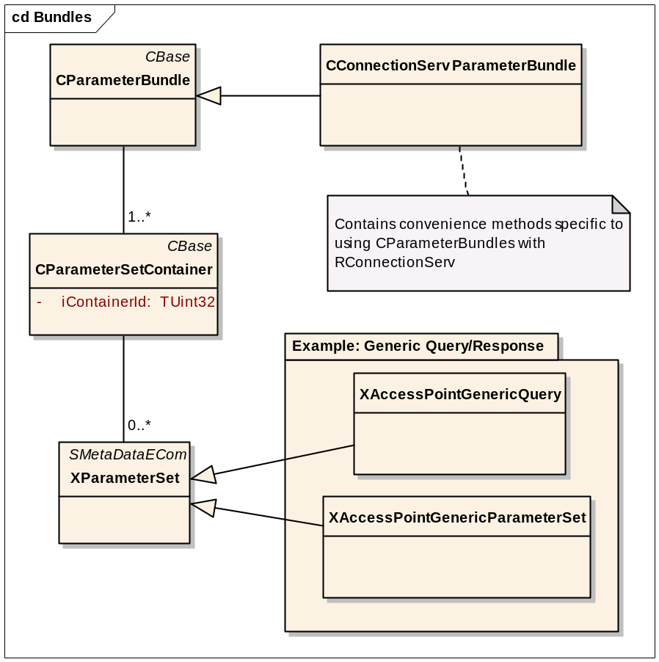
Figure 1: Data structures / types used by RConnectionServ

CParameterBundle
This is a class to hold general structured data
It can be seen as analogous to a table of data.
In the case of RConnectionServ, it does not represent a query / response from an actual database – it is just a way to represent the query/response to/from a variety of sources within the comms framework, for example: the status of active connections, hardware lines, commsdat.
The CParameterBundle owns 0-n instances of CParameterSetContainer, which it refers to by an array of pointers.

CParameterSetContainer
Continuing with the “table” analogy, a CParameterSetContainer represents a “record” or “row”.
In the case of RConnectionServ response, a CParameterSetContainer represents an Access Point.
In the case of RConnectionServ query, the CParameterBundle must only contain one CParameterSetContainer, but this may change in the future.
Each CParameterSetContainer owns 0-n instances of XParameterSet. It also contains a Container Id for quick indexing within the bundle.
In the case of RConnectionServ the Container Id is populated with an Access Point Id if appropriate. A scan of access points which are not yet known by commsdat (e.g. a wi-fi scan in a new place) would therefore yield 0 as the Access Point Id.

XParameterSet
This is a base class with no data. Classes containing data are derived from this. These classes are built as a data type plugin dll using netmeta and ECom.
The implementation of a new technology to the comms stack can define its custom data to be sent up/down between new client applications and the new functional plugins inside the comms process. Passing this custom data in new XParameterSet-derived types inside a CParameterBundle means CParameterBundle-based APIs (e.g. RConnectionServ) don’t need to change to support new data types and structures.
In the “table” analogy the XParameterSet-derived class represents a “group of fields” in the containing “row” (CParameterSetContainer).
In the case of the RConnectionServ query, the XParameterSet-derived class represents search criteria to match against the access points in the tier. It also specifies what information to return in the response. An example derivation is the generic access point query, see 5.2.3.1 below.
In the case of the RConnectionServ response, the XParameterSet-derived class represents a group of related properties of a given access point. An example derivation is the generic access point parameter set, see 5.2.3.2 below.

See the accompanying HowTo document [R3] for examples of the use of these classes.

XAccessPointGenericQuery
This must be present in every query on RConnectionServ, and contains the following items:
RArray<TAccessPointInfo> iApsToMatch;
This specifies which access points we wish to be in the result set.
If the vector is empty, all access points will be present in the result set.
If the vector contains (e.g.) [1,5], only access points with Ids 1 or 5 will be present in the result set.
TAccessPointStatusFilter iApStatusFilter;
This is a filter on the availability properties described in section 5.2.4.
Each property can have one of the following filter values:
EAccessPointFlagIgnore “ignore this property from the query.
don’t (go to any effort to) retrieve its value”
EAccessPointFlagMatchTrue “retrieve this property, only match if value is true”
EAccessPointFlagMatchFalse “retrieve this property, only match if value is false”
EAccessPointFlagMatchAny “retrieve this property, match any value”
So the MatchTrue and MatchFalse values have the ability to filter more access points out of the result set, and the Ignore/MatchAny values specify whether or not to return this value in the results for each access point.
RArray<STypeId> iParameterSetTypesToReturn;
This specifies which XParameterSet-derived data types we wish to be returned. Each and every data type required in the results must be mentioned here i.e. an empty vector here will yield an result set with no parameter sets. All such types have a Type() method which returns the STypeId as required by this vector. So iParameterSetTypesToReturn containing XAccessPointGenericParameterSet::Type() would generally be a bare useful minimum.

XAccessPointGenericParameterSet
This would generally be present in every result bundle coming back from RConnectionServ (unless omitted from the iParameterSetTypesToReturn list described above)
TAccessPointInfo iApInfo;
This contains the Access Point Id of the access point in question
TAccessPointStatus iApStatus;
This is a report of the availability properties described in section 5.2.4.
Each property has one of the following values:
EAccessPointFlagTrue
EAccessPointFlagFalse
EAccessPointFlagUnknown
EAccessPointFlagUnknown means either the property was deliberately not discovered (because the TAccessPointStatusFilter in the query specied EAccessPointFlagIgnore against that property), or that there was a problem reading the property.

Generic Access Point Properties
This describes more fully the availability properties introduced in section 2.1.
The following attributes are accessible to filter against (in TAccessPointStatusFilter in the XAccessPointGenericQuery). Their values are returned from a query in TAccessPointStatus in the XAccessPointGenericParameterSet.

Configuration
An Access Point must be configured in the phone to be usable and hence a known Access Point is more readily available for use than an unknown one (other things being equal). Some Access Points are restricted for use by certain clients
- Unknown Access Point
  - The access point has been reported by a remote peer, but is not yet configured for use in the device
- Known Access Point
  - The access point is configured for use in the device

Restricted
An access point marked as “restricted” is configured for use in the device, but is only available for use by particular clients or under particular circumstances.

Availability
The availability functions report on the status of one or more Access Points with respect to the remote service. Are the services the Access Point relies on available - on the device and over the air - so that the Access Point can report that it is available for use
- Availability unknown due to error
- Unavailable due to unknown error
- Hardware not enabled
- Carrier unavailable
  - as carrier is not detected or not stable enough for use according to the availability threshold policy configured for the Tier and/or MCPR.
- Available for use
  - Carrier is stable enough for use according to the availability threshold policy configured for the Tier and/or MCPR.

Connection status – “Started”
An access point is either connected or not on the device.
An access point that is already connected is more readily available than one that is not yet connected (other things being equal).
- Started Access Point
  - The access point is in use in one or more current connections on the device
- Non-started Access Point
  - The access point is not in use in any current connections on the device

Migration from deprecated functions in other Esock interfaces
The RConnectionServ API offers replacement implementations for some functions in other Esock interfaces that have been deprecated. Here is a list of deprecated functions
- RConnection::EnumerateConnections
- RConnection::AllInterfaceNotificaiton
- [Etc]

Migration from RConnection::EnumerateConnections
The RConnection function EnumerateConnections is supported by this interface as follows
- Connect to the Link Tier
- Call AccessPointStatusQuery (internal equivalent) with the following Query parameters
  - Started: MatchTrue
Internally an extension parameter set AccessPointPlaneStatus is used so the timings of connections going up / down can be modelled as closely as possible on the legacy comms framework.

Migration from RConnection::AllInterfaceNotification
RConnectionServ supports the AllInterfaceNotification functionality in the following way
- Connect to the Link Tier
- Call AvailabilityNotification (internal equivalent) with the following parameters
  - Started: MatchTrue
This means that when connections leave / join this defined set (“those which are started”), the client will be notified.

Changes to the Dynamic behaviour of the OS
This API causes no significant changes to the overall behaviour of the OS at run-time.

Proposed platform security capabilities
- The Platform Security capability required to use the RConnectionServ API itself is the same as that required for RsocketServ: ”Networking Services”.
Specifichnologies im
Further Information

People
Role | Person / People
Reviewers | Petr Smrz, Robert Lundie, Chris Woods, Mark Tovell,
Contributors
Location

References
No. | Document Reference | Title
[R1] | SXX.XXXnnn.nnn | Esock API Documentation
[R2] | SXX.XXXnnn.nnn | Design for new Comms Framework
[R3] | SXX.XXXnnn.nnn | Connection Server HowTo

Document History
Date | Version | Status | Author | Description
2006-09- | 0.1 | Draft | Viki Turner | First draft
2008-04-03 | 0.2 | Draft | Rob Lundie | Described bundles and parameters more fully

